VPC project - 01. High availability with the security provision.

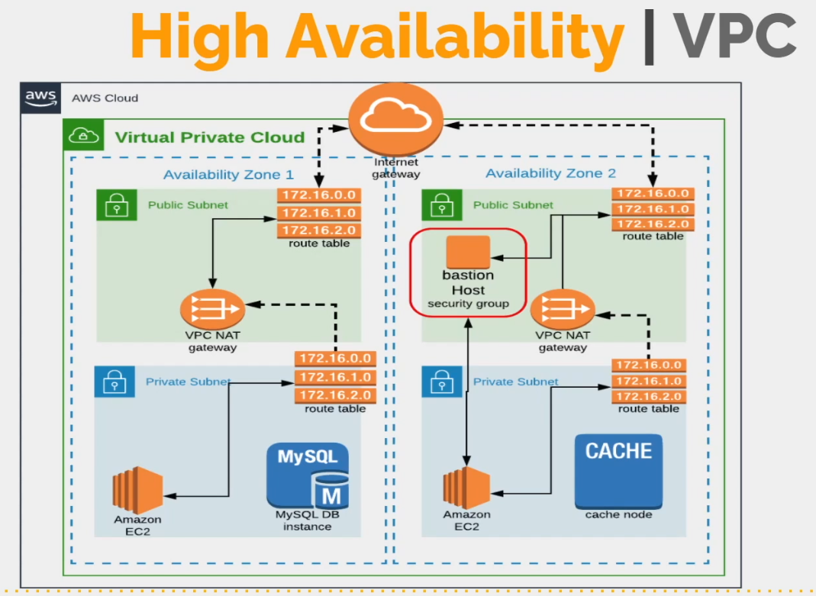

Region: us-west-1

VPC Range 172.20.0.0/16

4 subnets: 2 pub sub, 2 priv sub

2 zones: us-west-1a, us-west-1b

172.20.1.0/24 => pub-sub-1 [us-west-1a]

172.20.2.0/24 => pub-sub-2 [us-west-1c]

172.20.3.0/24 => priv-sub-1 [us-west-1a]

172.20.4.0/24 => priv-sub-2 [us-west-1c]

1 Internet GW

2 NAT Gateway

1 EIP

2 Route Tables : 1 Pub Sub RT, 1 Pub Sub RT

1 Bastion host in Pub subnet

NACL

1 more VPC => VPC Peering

* Create VPC = Vprofile-VPC
* Create 2 pub & 2 priv subnets
* Create IG = Vpr-RT
* Create pub-RT for pub subnets
  + Create route 0.0.0.0/0 -> IG
* Create NAT-GW -> pub subnet + EIP
* Create priv-RT for priv subnets
  + Create route 0.0.0.0/0 -> NAT-GW
* Install for pub subnets to get auto public Ips
* Enable DNS hostnames in VPC settings
* Create web EC2 and attach to priv subnet, web-sg, wave-key
* Create LB and attach to pub subnet